A Residential History of Art
Study Course on the Isle of Iona – 13th-18th April 2024
Featuring the work of The Glasgow Boys and The Scottish Colourists

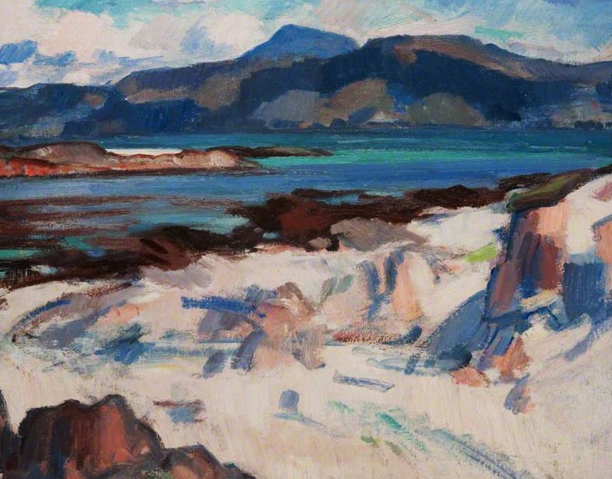

Scotland has always held a strong sense of location which has prompted painters to respond to its unique places. In particular, some of the Colourists found their inspiration on Iona and visited regularly. Alice will lead a series of lectures and discussion, with other related activities. A walk to the North End, favourite spot of Cadell and Peploe will be included, plus a visit to Iona Abbey, the Nunnery and, weather permitting, the Isle of Staffa. There will be time to discover other parts of this magical island which still today attracts artists and other craft activity.

The Argyll Hotel is delighted to host Alice Foster M.A., to lead this study holiday. They are offering a five night package for £900 with room upgrades available at an extra cost. This covers five night’s bed and breakfast accommodation, a three course evening meal on the first and last nights and five illustrated lectures with tea and coffee in the breaks.

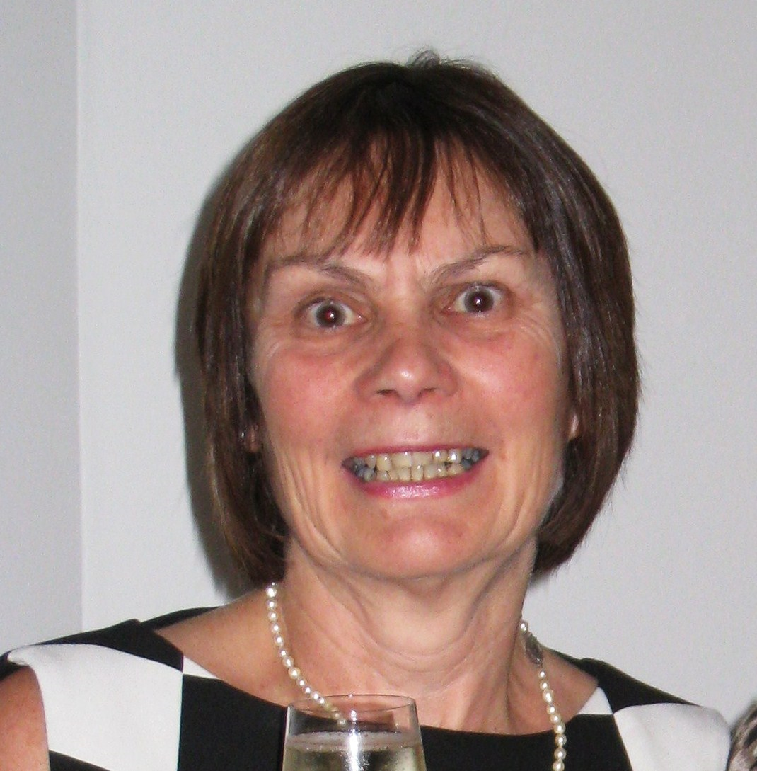
ABOUT THE SPEAKER – Alice Foster MA is a freelance art historian of more than 20 years’ experience and has been an accredited lecturer with The Arts Society since 2004. She has worked for Oxford University’s Department of Continuing Education, Oxford’s Ashmolean Museum and the Three Counties History of Art Society, amongst others. She has previously taken study groups to Europe and, in 2025, will take a lecture tour of Australia with The Arts Society.

